**INTRODUCTION**

In the conventional way of energy measurement and billing, energy usage recording and billing calculations are done manually. Hence the chance of flaws and errors due to parallax and similar reasons are certain. Other energy tampering faults should also be expected. Moreover this becomes a time consuming procedure as manual reading and calculations are required.Further there is no check - balance – verification procedure. There is always a chance of theft and corruption. Consumer is also not updated of his energy usage.

In Smart Metering Infrastructure, an automatic energy monitoring system is implemented wherein the consumer is updated about his energy consumption via his phone or pc. A Smart Load Controlling is included so that the consumers have a remote access to loads and thus can have much efficient energy management.

**ENERGY MEASURING UNIT CONCEPTS**

In order to measure the energy usage in this system, we use STPM01 power measuring IC. The measured energy is read by PIC microcontroller and is displayed in a 16*2 GLCD.The read data is simultaneously send to raspberrypi via UART terminal.

STPM01 is a power measuring IC from ST microelectronics which measures active power, real power &reactive power. It has additional tampering proof function to avoid any mishaps. The measured energy is either stored in its inbuilt registers or can taken as output pulses whose frequency is proportional to the energy being measured. The IC can be made to work in peripheral or standalone mode.

Measured energy is read from the IC using PIC microcontroller and is send serially to resberrypi. The instantaneous energy consumption is also displayed in a graphic LCD screen.PIC is programmed according to the mode in which the power measuring IC STPM01 is configured. When made to work in peripheral mode the 32 bit energy value stored in the internal registers of the IC is inputted serially and calibrated, but when in standalone mode, the count pulse output proportional to the active energy is measured using a timer function in PIC and is calibrated to get the instantaneous energy consumption.

The main circuits used in this unit are:

* Current sensing circuit
* Voltage sensing circuit
* Clock generation circuit
* Anti aliasing filter

**Current sensing circuit**

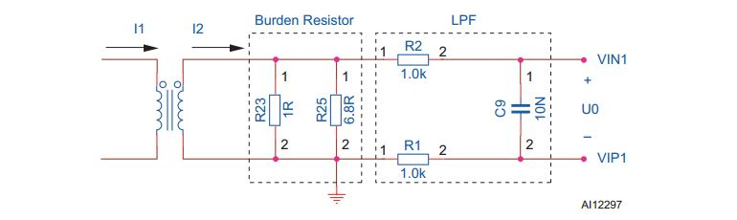

Fig: 1 CURRENT SENSING CIRCUIT

The current channel uses a current transformer to couple the mains current (see Fig 1). The Burden resistor is used to produce a voltage between VIN1 and VIP1 pins of STPM01. The Low-pass filter (LPF) is used to filter out the high frequency interference and has little influence on the voltage drop between VIN1 and VIP1.

**Voltage sensing circuit**

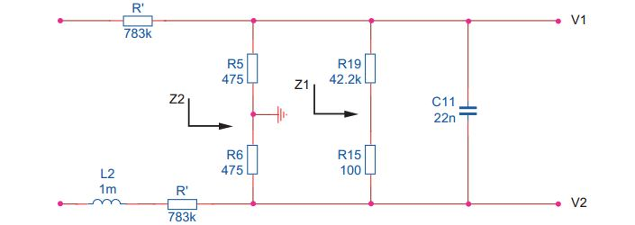

Fig: 2 VOLTAGE SENSING CIRCUIT

The STPM01 normally uses a resistor divider as voltage input channel. The 783k resistor is divided into three 261k series resistors, which ensures that a high voltage transient will not bypass the resistor. These three resistors also reduce the potential across resistors, thereby decreasing the possibility of arcing.

**Clock generation circuit**

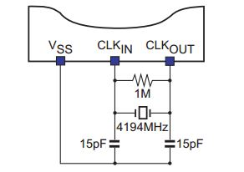

Fig: 3 CLOCK GENERATION CIRCUIT

**Anti aliasing filter**

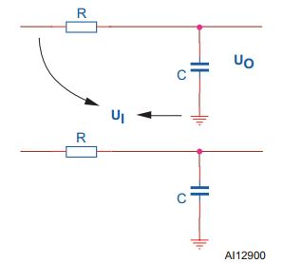

Fig: 4 ANTI ALIASING FILTER

The anti aliasing filter is a low pass filter which reduces high frequency levels that may cause distortion due to the sampling (aliasing).Filtering is easily implemented with a resistor-capacitor (RC) single pole circuit which obtains ana attenuation of -20 db/sec.

The following fig shows the full implementation of the energy measuring unit discussed, a capacitive power supply is also included.

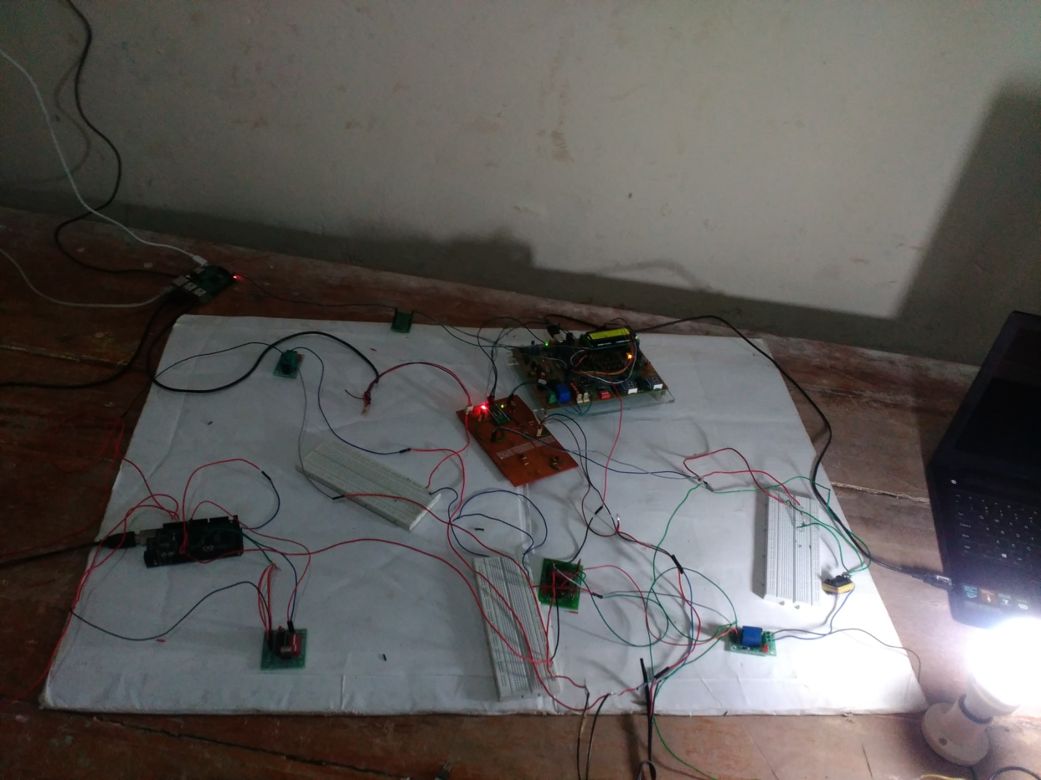

Fig : CIRCUIT IMPLEMENTATION

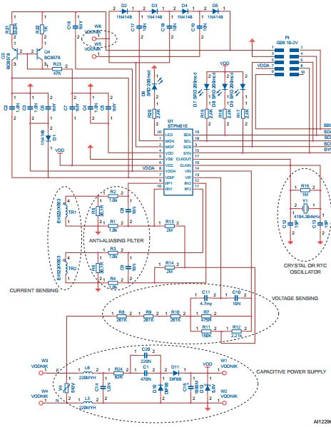

Fig: 5 STPM01 EXTERNAL CIRCUIT SCHEMATICS

**BLOCK DIAGRAM OF ENERGY MEASURING UNIT**

CLK

CURRENT SENSING CIRCUIT

STPM01

IC

**16X2 LCD DISPLAY**

PIC

**SERIAL TO RASP**

VOLTAGE SENSING CIRCUIT

**P N**

**Smart Load Control Unit Concepts**

**LIST OF COMPONENTS USED AND THEIR ARCHITECTURE**

1 STPM01  
2 PIC18F455  
3 16x2 LCD   
4 Raspberry Pi B+  
5 Level Shifter  
6 ULN2004A Relay   
7 GSM Module  
8 Arduino Mega   
9 Relays  
10 Modem  
11 Touch Switch  
12 Reed Switch

**STPM01**

The STPM01 is designed for effective measurement of active, reactive and apparent energy in a power line system using Rogowski coil, current transformer and shunt sensors. This device can be implemented as a single chip monophase energy meter or as a peripheral measurement in a microcontroller based  
monophase or 3-phase energy meter.

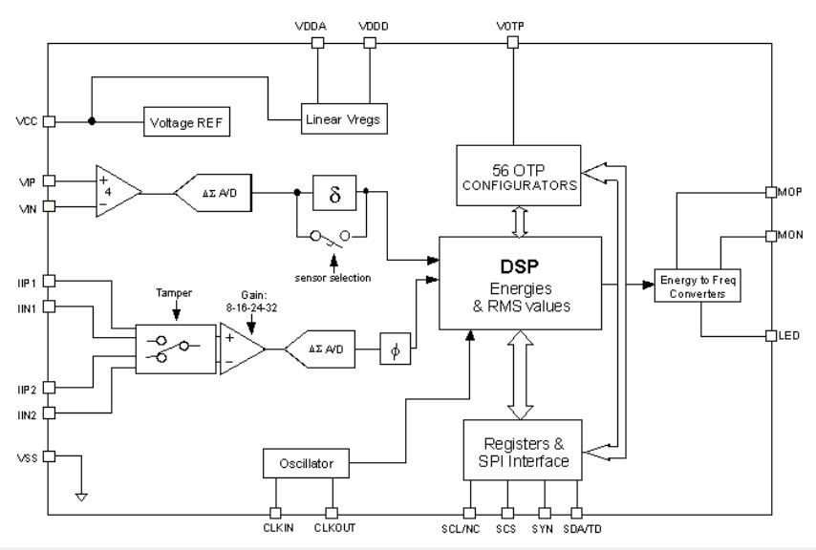

Fig: SCHEMATIC DIAGRAM OF STPM01 ARCHITECTURE

The STPM01 consists, essentially, of two parts: the analog part and the digital part. The former, is composed by preamplifier and 1 st order Δ ∑ A/D converter blocks, band gap voltage reference, low drop voltage regulator, the latter, is composed by  
system control, oscillator, hard wired DSP and SPI interface. From a pair of Δ ∑ output signals coming from analog section, a DSP unit computes the amount of consummated active, reactive and apparent energy, RMS and instantaneous values of voltage and current. The results of computation are available as pulse frequency and states on the digital outputs of the device or as data bits in a data stream, which can be read from the device  
by means of SPI interface.

Most of the functions are fully programmable using internal configuration bits accessible through SPI interface. The most important configuration bits are the two application bits, APL.  
Using these bits the STPM01 can be programmed as peripheral (APL = 0 or APL = 1) in microcontroller based meter systems or  
as standalone meter device (APL = 2 or APL = 3).

When used in standalone mode (APL = 2 or APL = 3), the STPM01 is able to directly drive a stepper motor. From signal AW (Active Wide band energy), a stepper driving signals MA and MB are generated by means of internal divider, mono-flop and decoder. The MA and MB signals are brought to the MOP and MON pins that are able to drive the stepper motor.

In the case where STPM01 is programmed to work in peripheral mode, all the SPI pins (SCS, SCLNCL, SDATD, SYN) are used only for communication purposes allowing the microcontroller to write and read the internal STPM01 registers. The peripheral mode has two further different configuration modes according to the status of the APL configuration bit. The APL bit status changes the function of MOP, MON and LED pins.

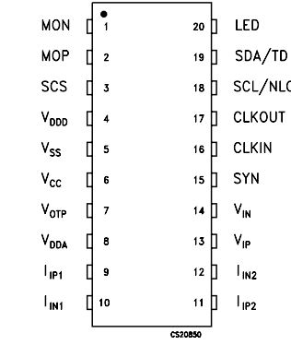

Fig: PIN CONFIGURATION

The STPM01 includes 8 status bits that provide several information on the current meter status. The status bits are the following:

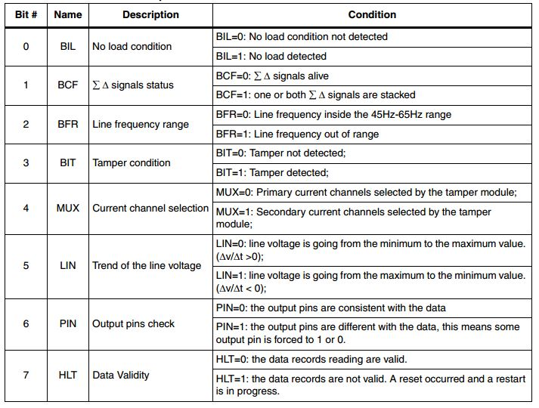

Table: STATUS BIT DESCRIPTION

All the configuration bits that control the operation of the device (CFL and CFH data records) can be written in a temporary or permanent way. In case of temporary writing the configuration bits value are written in the so called shadow registers which are simple latches that hold the configuration data. In case of permanent writing the configuration bits are stored in the OTP (one time programmable) cells that keep the information for an  
undefined period of time even if the STPM01 is without supply, but, once written, they cannot be changed anymore. The shadow registers are cleared whenever a reset condition occurs. Each configuration bit can be written sending a byte command to STPM01 through its SPI interface.

The STPM01 includes 8 mode signals, 3 of these are used  
only for internal testing purposes while 5 are useful to change some of the operation of the STPM01. The mode signals bit can be written using the normal writing procedure of the SPI interface.

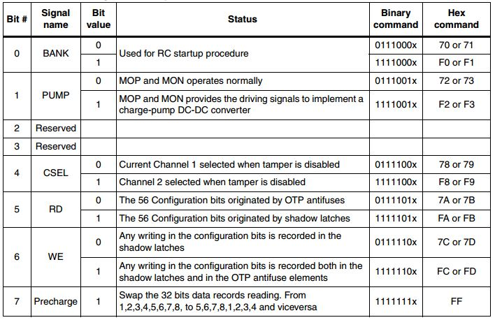

Table: MODE SIGNALS DESCRIPTION

**PIC18F4550**

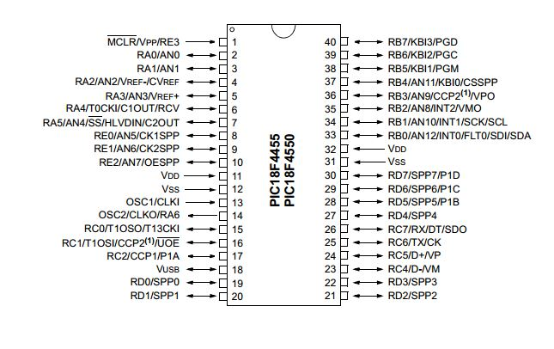

Fig: PIN CONFIGURATION

PIC18F4550 is an 8-bit advanced microcontroller of PIC18 family, which is equipped with enhanced communication protocols like EUSART, SPI, I2C, USB etc. It has internal counter/timer unit for pulse counting and HID class USB communication compatibility. The PIC reads the no. of pulses in proportional to energy being measured and simultaneously displays it in LCD as well as transfer it to raspberrypi serially.

**16x2 LCD**

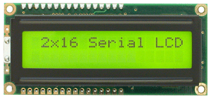

Fig: 16X2 LCD

A 16x2 graphical LCD unit is used in conjunction with PIC microcontroller to display the energy measured in real time. The LCD driver used here is IC HD44780U dot matrix liquid crystal display controller from Hitachi.

**Raspberry Pi B+**

**Level Shifter**

A level shifter is used to change (step up/down) the voltage of logic high. In this project, the serially transmitted data is having a logic high voltage level of 5V.But the raspberry pi GPIO pins are only 3.3V tolerant. So a bidirectional level shifter (5-3.3V) is used to facilitate safe serial communication.

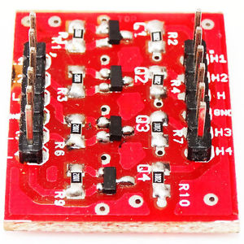

Fig**:** LEVEL SHIFTER

**ULN2004A Relay**

**Arduino Mega**

**Relays**

**Modem**

**Touch Switch**

**Reed Switch**

**PROGRAM FOR ENERGY MEASUREMENT AND SERIAL DATA TRANSMISSION**

*// LCD module connections*

*sbit LCD_RS at RD2_bit;*

*sbit LCD_EN at RD3_bit;*

*sbit LCD_D4 at RD4_bit;*

*sbit LCD_D5 at RD5_bit;*

*sbit LCD_D6 at RD6_bit;*

*sbit LCD_D7 at RD7_bit;*

*sbit LCD_RS_Direction at TRISD2_bit;*

*sbit LCD_EN_Direction at TRISD3_bit;*

*sbit LCD_D4_Direction at TRISD4_bit;*

*sbit LCD_D5_Direction at TRISD5_bit;*

*sbit LCD_D6_Direction at TRISD6_bit;*

*sbit LCD_D7_Direction at TRISD7_bit;*

*// End LCD module connections*

*unsigned int count;*

*char buffer[15];*

*char reactive[15];*

*void main(){*

*float energy,reac;*

*remap();*

*T0CON=0b10100010; // Mode selection of counter in timer0 PA4 pin as extern clk, prescaler-1:8,16 bit count*

*TMR0H = TMR0L = 0;*

*Lcd_Init();*

*Lcd_Cmd(_LCD_CLEAR); // Clear display*

*Lcd_Out(1, 1, "ENERGY in Wh");*

*UART1_Init(9600); // Initialize UART module at 9600 bps*

*Delay_ms(100); // Wait for UART module to stabilize*

*while(1){*

*count = (TMR0H << 8) + TMR0L; // 16 bit counter value*

*energy=count*(0.0028); // 1 min , 60 W bulb = 1Wh usage or 8 W CFL=0.13 Wh*

*reac=energy*(0.0008);*

*sprintf(buffer, "%4.3f", energy);// Format energy and store to buffer string*

*sprintf(reactive, "%4.3f", reac);*

*UART1_Write_Text("usage:");*

*UART1_Write_Text(buffer);*

*UART1_Write_Text("e?");*

*UART1_Write_Text("cost");*

*UART1_Write_Text(reactive);*

*UART1_Write_Text("r&");*

*LCD_Out(2, 1, buffer);*

*delay_ms(5000); // update LCD*

*}*

*}*

**RESULT**

* SMI measures the energy (in kWh) using the STPM01 IC and displays in the LED display through the PIC MCU efficiently.
* The Raspberry Pi acts as a control station for interfaces for various systems for monitoring and controlling purposes.
* The energy values and the other sensed values like the temperature are displayed in various websites using the open-source servers like openhab and displays in website widgets using dweet.io and freeboard.io.
* The values are displayed in the smart phones through android application installed in it using the open-source applications of arduino openhab.
* The loads are controlled manually using a touch switch with a feedback which enhances the energy management effectively.

**CONCLUSION**

In the present situation energy consumption is monitored manually. To reduce the manual efforts, improving accuracy and for increasing the load controllability, we need to have some kind of automated system monitoring all the parameters and functioning of the connections between the customer and electricity board.

In this system to save time of consumer, the energy consumption and corresponding price is displayed in their phones and also websites for the consumer benefits. By the implementation of this system the overall efficiency of operation of the electric board will improve

An attempt is made in this work to develop a system, where in complexity of the circuit is reduced and meter cost also get reduced.

The consumers and the suppliers can be benefited by using the Smart Metering Infrastructure (SMI).

**FUTURE SCOPE**

Electricity usage can be monitored directly by K.S.E.B using broadband functionality and the connections can be made tamper proof by additional sensors installations.

Consumer friendly load functionality can be enhanced via smart phone interfacing by introducing individual room controls and complete Home Automation which further improves the energy usage efficiency and helps in energy conservation.

Better load forecasting and management can be done in the advancements of SMI for both customers as well as suppliers.

Energy Suppliers will be able to improve the accuracy of forecasting their maximum load demand at different seasons and at various times of day and will be able to purchase energy contracts more efficiently**.**

**REFERENCE**

* *http://www.microchip.com*
* *http://www.st.com*
* *Design and Development of PIC Microcontroller Based 3 Phase Energy Meter  
  Thousif ahamed1, A.Sreedevi2 Department Electrical and Electronics Engineering, R.V. College Of Engineering, Bangalore, Indias1,2  
  (International Journal of Innovative Research in Science, Engineering and Technology)*
* *https://github.com*
* *http://www.instructables.com*
* *http://www.edaboard.com*